|  |  |
| --- | --- |
|  | Bristol County Savings Bank  Commitment. Stability. Community. Data Analytics Use Cases |

**CoStar Extract**

**Programmed by Chad Doorley**

**Executive Summary**

The CoStar Lender Platform is piece of software from The CoStar Group that provides stress-testing and analytics on Commercial Real Estate portfolios, specifically on Non-Owner Occupied Commercial Real Estate. The Bank has engaged in a contract to run the Bank’s portfolio through their model to receive this service to better monitor Commercial Real Estate loans. The extract is created from COCC data through Alteryx. It is transformed into a specific template that is readable by the CoStar model and it is sent to them via SFTP (Secure File Transfer Protocol). There are two tabs in the CoStar Extract: Permanent and Construction. Information such as basic loan information, collateral types, appraisal values are included on this extract.

**Benefits and Potential Gains:**

* BCSB will benefit from enhanced stress testing and more data on the Non Owner Occupied CRE portfolio
* The manual creation and updating of this report would be extremely time consuming
  + Through the automation process that has been created, this extract file can be compiled and updated in under 5 minutes and can be sent off to CoStar automatically.
  + No risk of human error transposing data, as the logic and calculations are written ahead of time and can be clearly audited.
* The CRE extract can be used as a data integrity check to other loan review reports and will promote a better understanding of the commercial real estate portfolio.

**Output of the Report:**

There are 2 sheets that are output to the excel file that will be named ‘Lender Input File Demo.xlsx’

* ‘Permanent Loans - Raw’: Includes all non-construction Non-owner Occupied CRE loans
* ‘Construction Loans – Raw’: Includes all construction loans in the CRE portfolio (some may be non-owner occupied and some may become owner occupied)
* 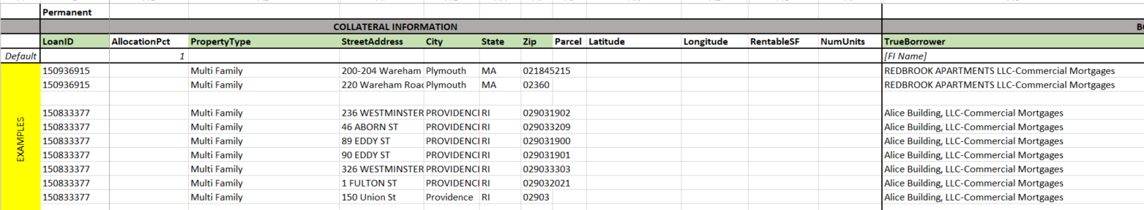The other sheets are not utilized and data is not updated to those sheet.

The workflow, output, and associated documentation can be found at:

\\00-DA1\Home\Share\Line of Business_Shared Services\Commercial Credit\CoStar\

**Filters and Calculations Utilized:**

* COCC data filters for Permanent sheet:
  + Major = “CML”
  + Current Account Status = “ACT” or “NPFM” (Active or Non-Performing)
  + FDICCATCD = “RENO” or “REMU” (RE Non Owner Occ or RE Multifamily call code)
  + ARC ARM loans excluded
  + Minors: “CI07” (ACH Manager) and “CM09” (Swap Exposure loans) were excluded
* Calculations for Permanent sheet:
  + OriginalTotalLoanAmount = if null, then Credit Limit Amount, else OriginalTotalLoanAmount
  + Amortization Term / 30.4 and rounded to the nearest whole number (to get this field in ‘Months’)
  + Loan Index field converted to their benchmark values (table included in data dictionary)
  + Reset Rate Frequency was converted to ‘Months’
* Total Loan Amounts and Appraisals have been adjusted for participations bought/sold according to the logic shown below:

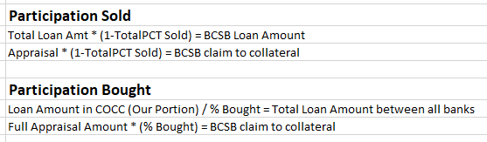

* COCC data filters for Construction sheet:
  + Major = “CML”
  + Current Account Status = “ACT” or “NPFM” (Active or Non-Performing)
  + FDICCATCD = “OTCN”
  + ARC ARM loans excluded
  + Minors: “CI07” (ACH Manager) and “CM09” (Swap Exposure loans) were excluded
* Calculations for Construction sheet:
  + OriginalTotalLoanAmount = if null, then Credit Limit Amount, else OriginalTotalLoanAmount
  + Amortization Term / 30.4 and rounded to the nearest whole number (to get this field in ‘Months’)
  + Loan Index field converted to their benchmark values (table included in data dictionary)
  + Reset Rate Frequency was converted to ‘Months’
* Formatting:
  + Several formatting operations are all completed through Alteryx report writing capabilities.
* Other:
  + Upon completion, the report is placed into a File Explorer location that is set to send the file through a Secure File Transfer Protocol to CoStar and their platform will be updated automatically